Even and Odd Numbers Reference Sheet

Visit the class website for the even and odd numbers video presentations.
http://mrsalbro.weebly.com/even-and-odd-numbers.html

Even and Odd Chant

0, 2, 4, 6, 8 being EVEN is just great!
1, 3, 5, 7, 9 being ODD is just fine!

E V E N
O D D

- Even numbers are multiples of 2.
- To determine if a number is EVEN or ODD, always look at the ONES place.

13,729
odd
26,847
odd
530
even
9,356
even
851
odd
4,894
even

Odd
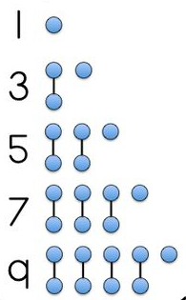
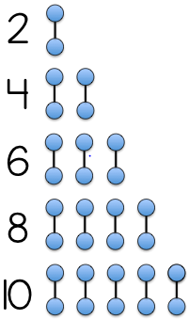
Even

Adding
Even and Odd Numbers

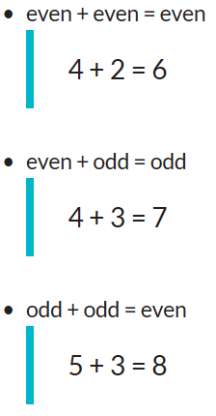
Subtracting
Even and Odd Numbers

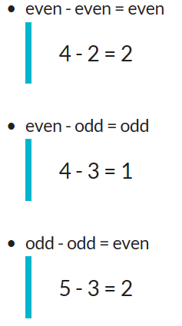
Multiplying
Even and Odd Numbers

