matter |  | Anything that has mass and takes up space.
mass |  | The measure of how  much matter is in an object.
volume |  | The amount of space  an object takes up.
atoms |  | The smallest units of matter.  The basic building blocks of  all matter. ______ are made  up of protons, neutrons, and electrons.
physical property |  | Anything you can observe about an object by using one or more of your senses.  For example, color, texture, size,  shape, volume, odor, etc.
plasma |  | The state of matter that is  an electrically charged gas. Found in stars, lightning, and some lightbulbs.
gas |  | State of matter with  no definite shape and  no definite volume.
solid |  | State of matter with  a definite shape and  a definite volume.
liquid |  | State of matter that has  a definite volume, but  no definite shape.
precipitation |  | The liquid and solid  water particles that  fall from the clouds.  For example, rain, snow, sleet, or hail.
temperature |  | The measure of how hot  or cold something is.
heat |  | The movement of  thermal energy.
evaporation |  | When thermal energy  is added, and a liquid becomes a gas.  Example: boiling a pot of water
energy |  | The ability to do work.
condensation |  | When thermal energy is taken away, and water vapor (gas) changes into a liquid.  Example: water that gathers on a  bathroom mirror after a hot shower
Chemical Change |  | Physical Change or Chemical Change  burning wood
Chemical Change |  | Physical Change or Chemical Change  rusting
Physical Change |  | Physical Change or Chemical Change  cutting a sheet of paper
Chemical Change |  | Physical Change or Chemical Change  baking a cake
Physical Change |  | Physical Change or Chemical Change  chopping wood
Physical Change |  | Physical Change or Chemical Change  an ice cube melting
Physical Change |  | Physical Change or Chemical Change  breaking a  drinking glass
Chemical Change |  | Physical Change or Chemical Change  rotting fruit
Physical Change |  | Physical Change or Chemical Change  freezing juice into  a popsicle
Chemical Change |  | Physical Change or Chemical Change  digestion
gas |  | Based on the arrangement of the atoms, is this a solid, liquid, gas, or plasma?  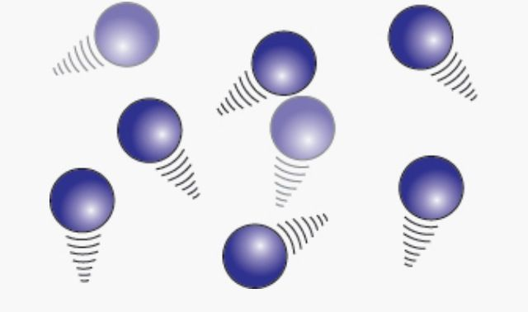
solid |  | Based on the arrangement of the atoms, is this a solid, liquid, gas, or plasma?  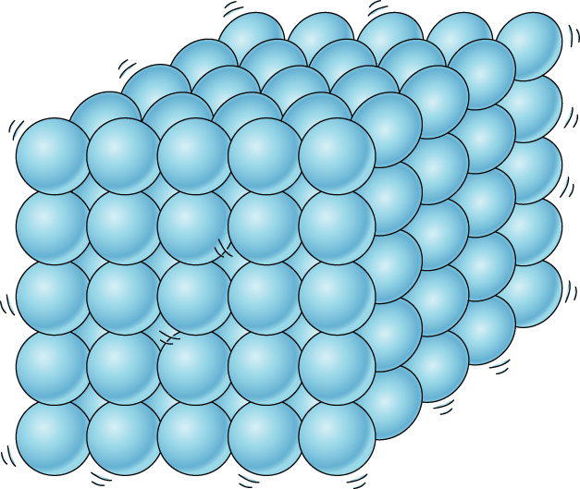
plasma |  | Based on the arrangement of the atoms, is this a solid, liquid, gas, or plasma?  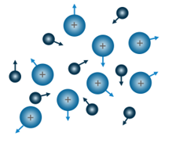
liquid |  | Based on the arrangement of the atoms, is this a solid, liquid, gas, or plasma?  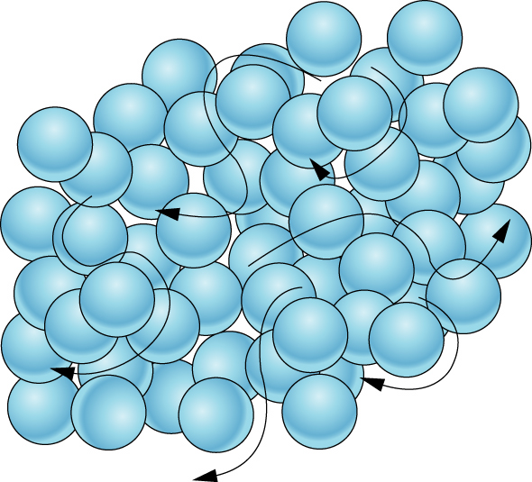
0° Celsius |  | What is the Celsius freezing point of water?  (a liquid becomes a solid)
32° Fahrenheit |  | What is the Fahrenheit freezing point of water?  (a liquid becomes a solid)
100° Fahrenheit |  | What is the Celsius  boiling point of water?  (a liquid becomes a gas)
212° Fahrenheit |  | What is the Fahrenheit boiling point of water?  (a liquid becomes a gas)
Physical Change |  | A change from one state  to another without changing  the chemical properties of  the substance.  Ex. changing size, shape, or form.
Chemical Change |  | A change that causes  a new substance to  be formed.

